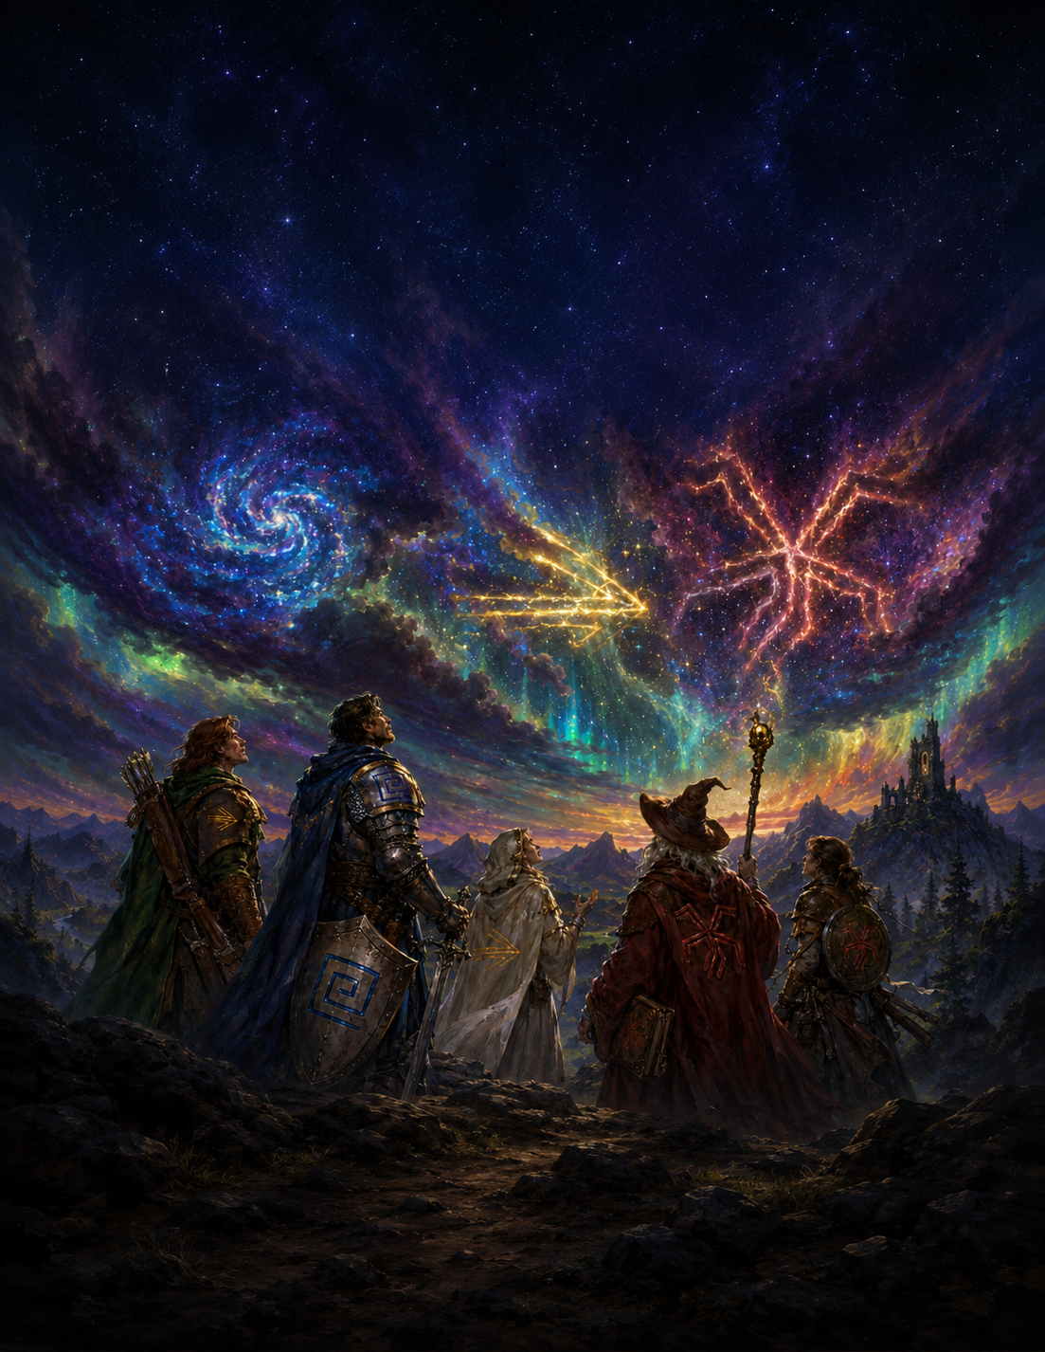
The Realm of Prima
Player Handbook

Prima
Playtest Draft v0.1

A Note on This Document
This is an Early Playtest Draft. Systems, numbers, and terminology are subject to change based on feedback and playtesting. Critique is welcomed!

The artwork in this documentation is a combination of crude sketches, stock art, and AI-Generated Images at this point in the design process. Please note that this is temporary and purely for layout and mood purposes, as a massive wall of text would simply not be pleasant to read. Due to frequent changes and rapid iteration cycles, using handmade art for every piece at this phase in the process would not be possible.
All release art will be original commissioned, vetted, and human hand-drawn work.
Additionally, all ideas and writing come from the brain of the creator first and foremost! Any LLM usage is purely for tedious math, data aggregation, and formatting purposes – the Prismatic System is by humans (Me!) for Humans (You!) and will stay that way
Just to reiterate and be extra clear – zero official, non-draft content will leverage any AI art or writing. The system will be polished by commissioned artists, writers, and passionate community members first and foremost.

Please direct all feedback toward jackvalladares@gmail.com
or join our discord here

Version 0.1 – 5/20/2026

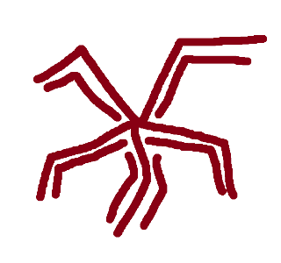
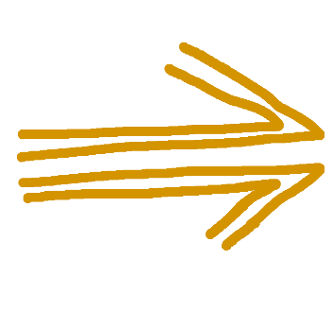
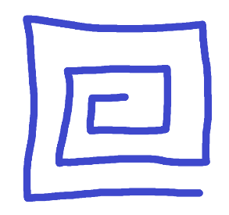
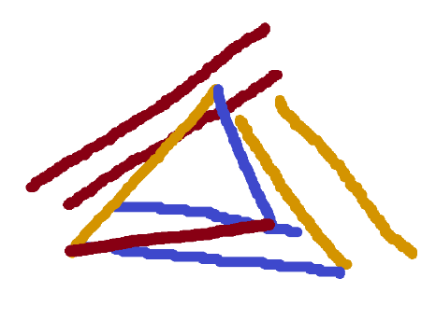
Introduction
Welcome to the Realm of Prima
Prima
“The stars are deeply obscured behind a dense wall of clouds in the sky. Despite this, the atmosphere glows with the primal light of creation – twinkling a million different colors above the adventurers’ heads.”

The Prismatic Realms are woven in the language of Prima.
Since the dawn of the very first societies marked by the earliest notches on the timeline, Prima has been observed and understood in many ways under many different names, but a single, universal truth has always been known by all: Prima is energy in its most raw form. Chaotic, Transformative, Constructive; untainted by bias or intent.
This curious substance is said to be cosmic in origin, as it is found in its most dense and pure form the higher one travels into the atmosphere – giving it a religious connotation in many societies. Visually, it presents itself as a white plasma with a deep pearlescent hue – glittering with more colors the more deeply it’s observed. Prima only vaguely interacts with the material world – lightly contorting around and permeating physical objects and feels sterile and vaguely energizing if one were to reach into it.
Prima is as plentiful as it is precious; existing abundantly in the natural world following the natural ebb and flow of any process involving energy. Just as a volcanic eruption or violent ocean storm would be marked by heavy amounts of Prima empowering the phenomenon, so too would it lightly glitter in a gentle breeze on an unremarkable day. To find a vacuum of Prima.
Therefore, a common axiom is known ironically as a simple equation akin to basic arithmetic – To Exist in the Prismatic Realm is to exist in a World of Prima.
Paradoxically, Prima in this form, despite being so ubiquitous, is simply a platonic ideal than an actual thing in reality. To say that a process involves Prima is akin to saying it involves Energy. Is this in the form of heat or electrical energy? Potential or kinetic? Perhaps even centrifugal? While all of these processes are technically energy in different forms, energy is understood to have shape and properties as it exists in the real world. This is also, then, the case with Prima. Pure, pearlescent, cosmic Prima looks nice as a balanced equation or twinkling substance in the stars above, but Prima in the world is stained by intent and bias; imbued with a shape that determines its usefulness. This is known as Prisma.

Prisma
Prima is Prima given form – imbued with intent and bias in a process known as Staining

Staining occurs whenever any interaction occurs between Prima and the world. This is true materially and immaterially – even thoughts, ideas, and culture will Stain Prima in this manner. Therefore – all Prima exists in the world as Prisma, as there exist no true vacuums devoid of material concept or immaterial concept. The most Un-Stained Prisma can be found in the upper-atmosphere approaching the cosmos, yet even there one will observe traces of Staining when viewed closely enough.
Because every interaction with the world affects the properties of Prisma, no two samples are identical. All Prisma is technically unique, being endlessly stained and molded by the world around it. However, past a certain point these differences are arbitrary and exist on a spectrum that can be divided into different functional categories, which are derived as follows -
Each variant of Prisma is defined first and foremost by its color. Even with the naked eye, it is a simple process to discern between Prisma that is Red, Yellow, and Blue. This is a clean heuristic that quickly informs an observer as to the other properties of the Prisma.
Each color of Prisma then has an elemental affinity as well. Yellow Prisma, for example, is often stained by the winds and waves – associated with lightning, wind, and water. This is reflected in its shape – as this same Yellow Prisma can best be described as small jolts of restless electricity dancing with the wind. Are these phenomena first perpetuated by large amounts of Prisma in this form? Or is this Prisma first Stained by these environments? This is a great chicken-and-egg question, with likely truths on both sides of the equation.

Finally, each color of Prisma has a philosophical affinity. Continuing along with Yellow Prisma, living creatures and environments exhibiting Yellow traits are defined by the idea of flow. Mercantile seafaring societies; transient wind elementals drifting through the land; innovative artists pushing the limit of their craft. Much like elemental affinity, one can endlessly posit whether these cultures Stained the Prisma of a region, or if they were molded by existing Prisma. One again – likely truth on both sides.

Understanding the nature of each category – or Domain – of Prisma is absolutely essential to properly utilizing it.
Just as roaring water can be used to douse fires and the heat of a flame can be used to light a candle, each Prismatic Domain’s properties lend them to particular types of utilization. And, as a flame can be combined with water to create a steam engine, so too can differing types of Prisma be utilized in a sum greater than their individual parts.

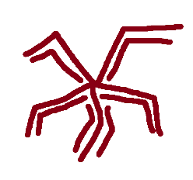
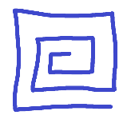
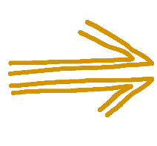
Chapter 1
The Prismatic Domains
Orders of Prisma
“A wise old wizard and his three apprentices come upon a stone wall blocking their path. ‘Let’s destroy it! I love a good explosion!’ proposes the first apprentice, bathed in a fiery red aura. ‘No need; I can easily create a door and improve this gaudy wall’ the second interrupts, his hand enveloped in a deep, rigid blue. ‘Both good ideas, but I can change the wall into a gas. Or perhaps water? That’d be a lot more fun’ the third chimes in, as electric yellow sparks leap from his wand. The old wizard, meanwhile, simply walks around the wall.
- From Foundations of Prismatic Theory, Chapter 1, First Page, every edition since the First

As has now been established, Prisma is Stained Prima and exists across several different Domains.
All Prisma is not created equal, and the six Primary Domains of Prisma are designed between Lower Order Domains and Higher Order Domains.

Lower Order Prisma

Lower Order Domains are considered the Primary Colors of Prismatic Theory. These are more common in the natural world, easier to Stain manually, and generally considered more primal and rudimentary – with a vast amount of applications in everyday life. These are as follows:
Entropic (Red) Prisma

Representing Entropy and decay. Associated with Fire and Poison
Fabric (Blue) Prisma
Representing Fabrication and iteration. Associated with Earth and Ice

Morphic (Yellow) Prisma
Representing Flow and the currents. Associated with Storms and Seas.

These are said to represent the fundamental governing forces of the natural world. Cycles of erosion, movement, and deposit upon which the world is shaped – and long-form geological observation hints that every region of the world has gone through cycles of Red, Blue, and Yellow when zoomed out enough.

Though the categorization and selection of these Domains as the fundamentals is arguably arbitrary and chosen out of convenience and abundance, these are nonetheless the Domains through which Prismatic Understanding is built.
Given the nature of Living creatures as vessels of Prisma, most see themselves as some combination of Entropic, Fabric, and Morphic Prisma. Much like Prisma itself, no one being is comprised solely of a single Domain of Prisma, but methods of viewing one’s own ratio will most often yield something mapped out to a combination of Red, Blue, and Yellow to some degree.

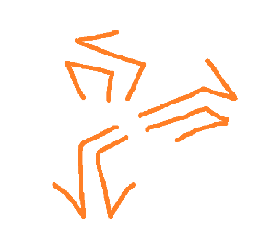
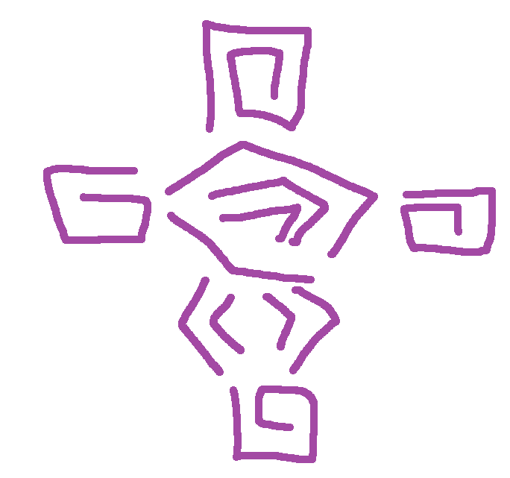
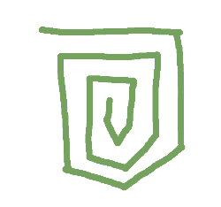
Higher Order Prisma
Higher Order Domains are considered the Secondary Colors of Prismatic Theory. Just as many view the color Purple as a composite of Red and Blue, so too is Purple Prisma viewed as the intersection of Entropic and Fabric Prisma.
As has been established, no Inkling of Prisma is truly stained a single color. The deepest Red will still have some amount of Yellow and Blue. Domains simply observe and categorize the dominant, functional color.
Within this system, Higher Order Prisma represents a roughly equivalent convergence of Lower Order Prisma. Prisma stained at the intersection of Flow and Fabrication takes on the properties of both, visually manifesting in a deep Green color. The exact shade, as with all Prisma, might have a slight yellow or blue bias – but visibly green Prisma takes on its own flavor with its own unique properties. These Higher-Order Combinations are as follows:
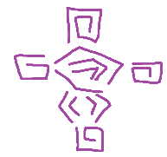
Invigorated (Purple) Prisma
Representing Body as the intersection of Entropy and Fabrication. Associated with the material and mental self.
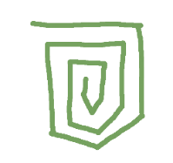
Fortified (Green) Prisma

Representing Artifice as the intersection of Fabrication and Flow. Associated with abstract and concreate engineering.
Animated (Orange) Prisma
Representing Force as the intersection of Flow and Entropy. Associated with harnessing and transmuting the elements.

These Domains are said to represent aspects of self. Body as the vessel one inhabits. Artifice as the ingenuity and skill through which one makes their mark. Force as projection of self into the world.
Most known methods of manually Staining Prima are strictly in the form of Lower Order colors – requiring the Prisma output to again be combined into Higher Order Prisma in a second step at the cost of efficiency. Though direct Higher-Order Staining exists, the necessary components and craftsmanship are few and far between. This reality, combined with the fact that Higher Order Prisma is less common in the natural world, only reinforces the understanding of these colors as composites instead of standalone.
Higher order Prisma, as a result, is less ubiquitous in day-to-day life. Processes that utilizes this Prisma are often specialized and targeted – such as a skilled Artificer requiring a supply of Fortified Prisma for a project.
Beings whose souls exhibit clear Higher-Order Prisma are either born into environments with these unique convergences or pursue great mastery and study of these Domains.
A keen eye might notice a missing domain in the form of an equal 3-way intersection. Curiously, a full 33% / 33% / 33% split between the three Lower Domains is entirely absent in nature and seems impossible to synthesize, as the Staining process itself carries inherent bias beyond the intended color. The most successful attempts, though, result in pale pearlescence - suggesting that this balance yields pure Prima.

Special Order Prisma
Special Order Prisma is the final classification of Prismatic Domains, and likewise the most arbitrary and uncommon.

Entropic Prisma (Lower)
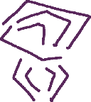
Necrus (Red Expression, Blue Inflection)
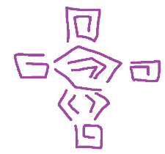
Invigorated Prisma (Higher)
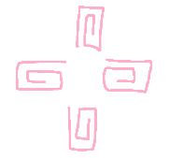
Vitus (Blue Expression, Red Inflection)

Fabric Prisma (Lower)

This Prisma denotes specialized ratios of Lower Order Colors resulting in highly specific types of Prisma.
Though these might technically appear in nature on virtue of all Prisma being across a wide spectrum of colors, this is mostly in the form of small pockets and sub-ecosystems with just the right intersection and does not meaningfully align with broad environments on a map.
The combinations that can be used to derive different Special-Order classifications of Prisma are technically endless – as an 82:18 and 78:22 Red-Blue split might have extremely subtle differences in use-cases and aesthetic. But the most widely used and recognized Special-Order Prismatic Domains are offshoots of Higher-Order Domains where there is clearly more of one color than the other. The dominant color in this scenario is known as the Expression, and the supporting one as the Inflection.
Special Order Domains are not considered true Categories of Prisma and are instead described as a Domain under which a variety of spells, abilities, and use-cases can be categorized.
Taking this into account with Entropic and Fabric Prisma as an example, then, we can derive 5 different Prismatic Domains:
All the commonly accepted Special Orders of Prisma will be covered in the master table at the end of this section for easy reference.
Though no known souls exhibit a direct attunement toward Special Order Prisma, one’s affinity for Higher and Lower Orders often map out to study in several Special-Order Domains of Choice. A soul with high red and moderate blue attunement might be encouraged to learn the ways of Vitus, for example. Learning these abilities tends to signify high amounts of Prisma mastery, and a commitment to a particular path of study.

Picking Your Path
When creating a character and navigating the world, the initial Prismatic Attunement chosen is a crucial part of their personality and style.
This Attunement – also known as a Fingerprint – will naturally ebb and flow as they accumulate experiences and mastery. One who is deeply traumatized by an Entropic disaster might see a noticeable increase in the Red Prisma woven into their soul. Similarly, a deep understanding of Channeling Invigorated abilities can cause an understanding of the Domain that transcends its Red and Blue Parts, injecting a purple tint into the soul itself.

Let’s now explore the domains to properly understand the nuances of each. Keep in mind the environment, personality, and strengths/weaknesses of each and how that might influence a character attuned in such a way.

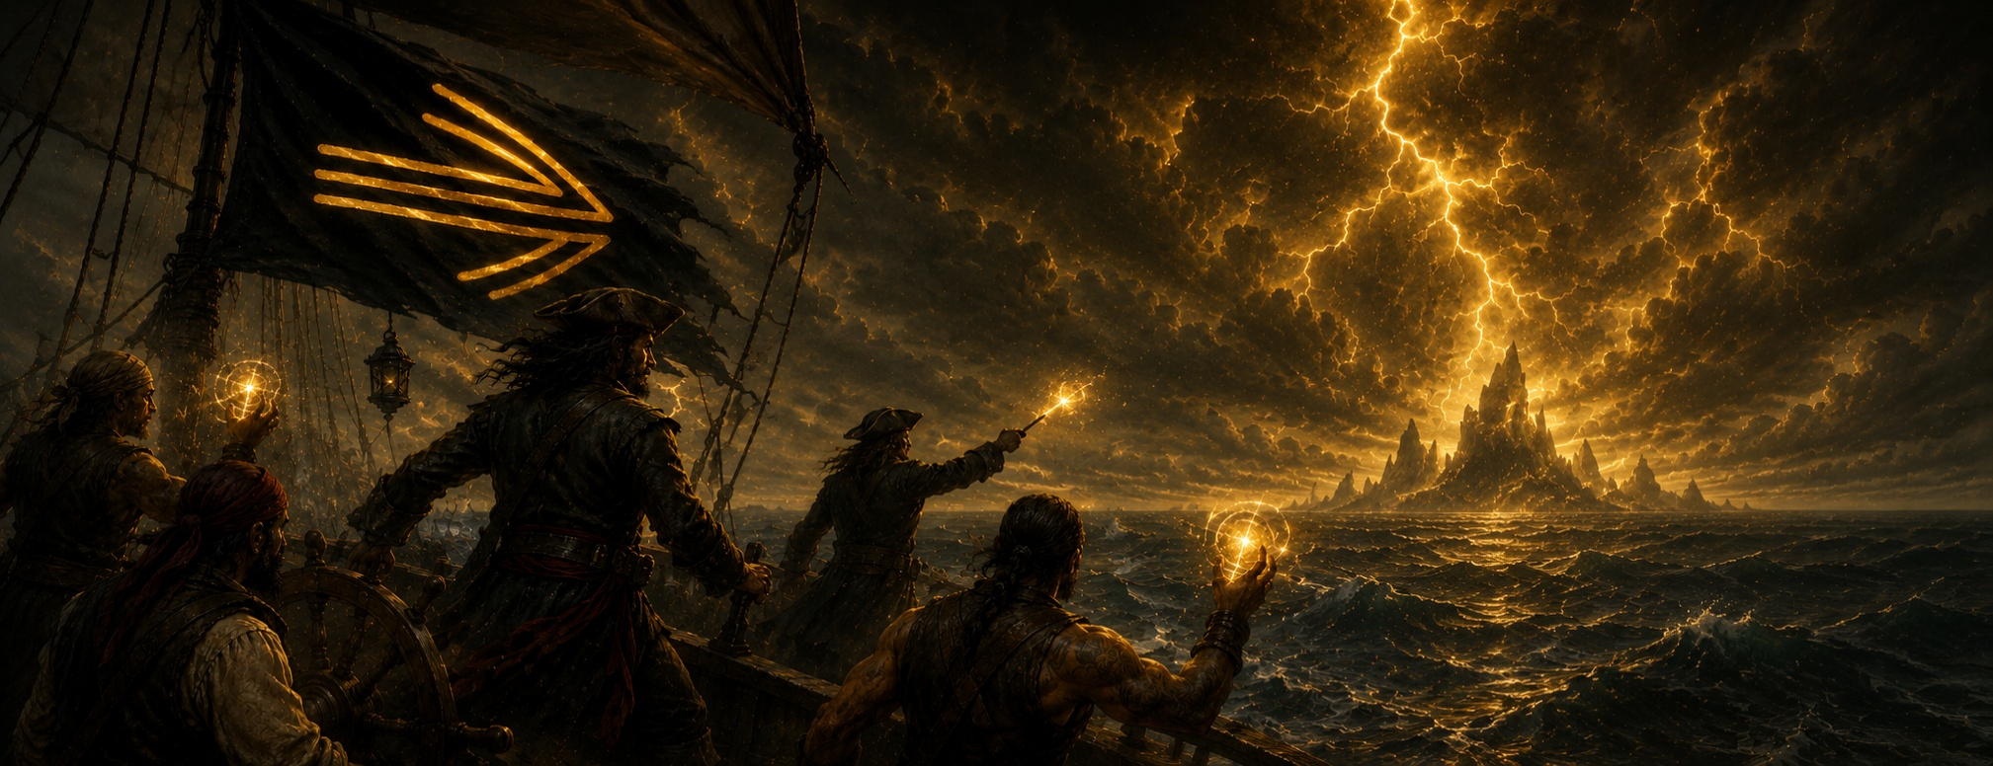

Morphic Prisma (also known as Yellow Prisma) is Flow made manifest.
Elements: Lightning, Wind, Water, Gravity
Animals: Birds, Fish
Deity: Morphos

Color: Yellow
Philosophy: Flow
Neighbors: Animated and Fortified

v
Lower Order Domain
Morphic Prisma
Flow represents the qualities of movement, innovation, and adaptability. Natural phenomena and creatures embodying this principle are often thought of as restless travelers, living in the moment and thinking outside the box as a natural state of being.
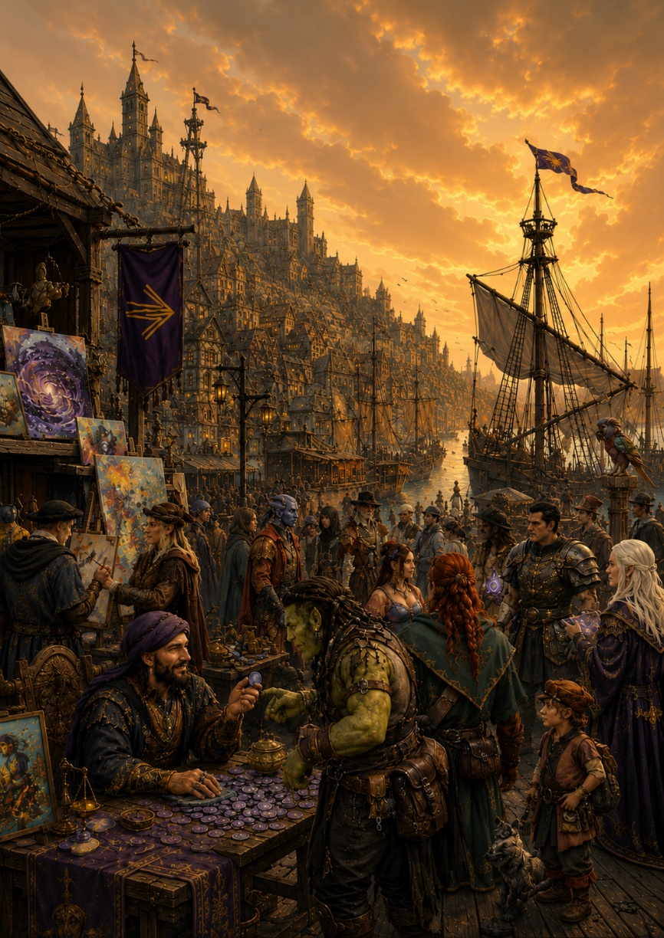
This yellow Prisma presents itself as an atmosphere of fickle, windy, electrifying currents – most commonly tied to lightning storms, oceanic environments, and gravity. Cultures shaped by Morphic Prisma are defined as progressive, mercantile, and nomadic. Seafarers who follow the winds of change. Merchant cities with bustling ports – swapping out resources and gladly accepting expats from every background; welcoming new ideas and bold, groundbreaking arts and sciences.
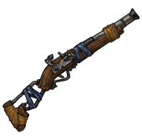
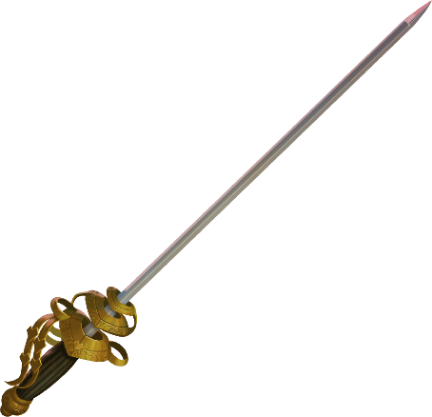
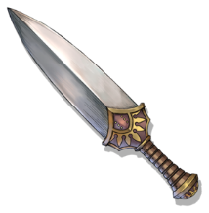
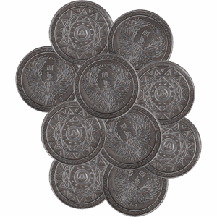
Prima is most potently stained with a Morphic Tint when it comes into contact with Tidestone; a category of malleable rock formed in large bodies of water, carved by the winds and waves. Tidestone, when refined, manifests as a dark glass or metal with a deep purple undertone, and lends itself well to intricate artifices such as daggers, firearms, rapiers, and currency.
Oceans and Islands tend to be the most intuitively morphic environments. However, when Morphic Prisma converges in other places, the trademark motion and flow is made manifest. Yellow forests tend to look like rainforests – wet and fast-growing with rapidly-shifting canopies, and with diverse bird and fish populations. Yellow Volcanoes have fast-moving plumes with lightning-struck, stormy atmospheres. And yellow caves are marked by underground rivers, gas-vents, and unstable rock formations.

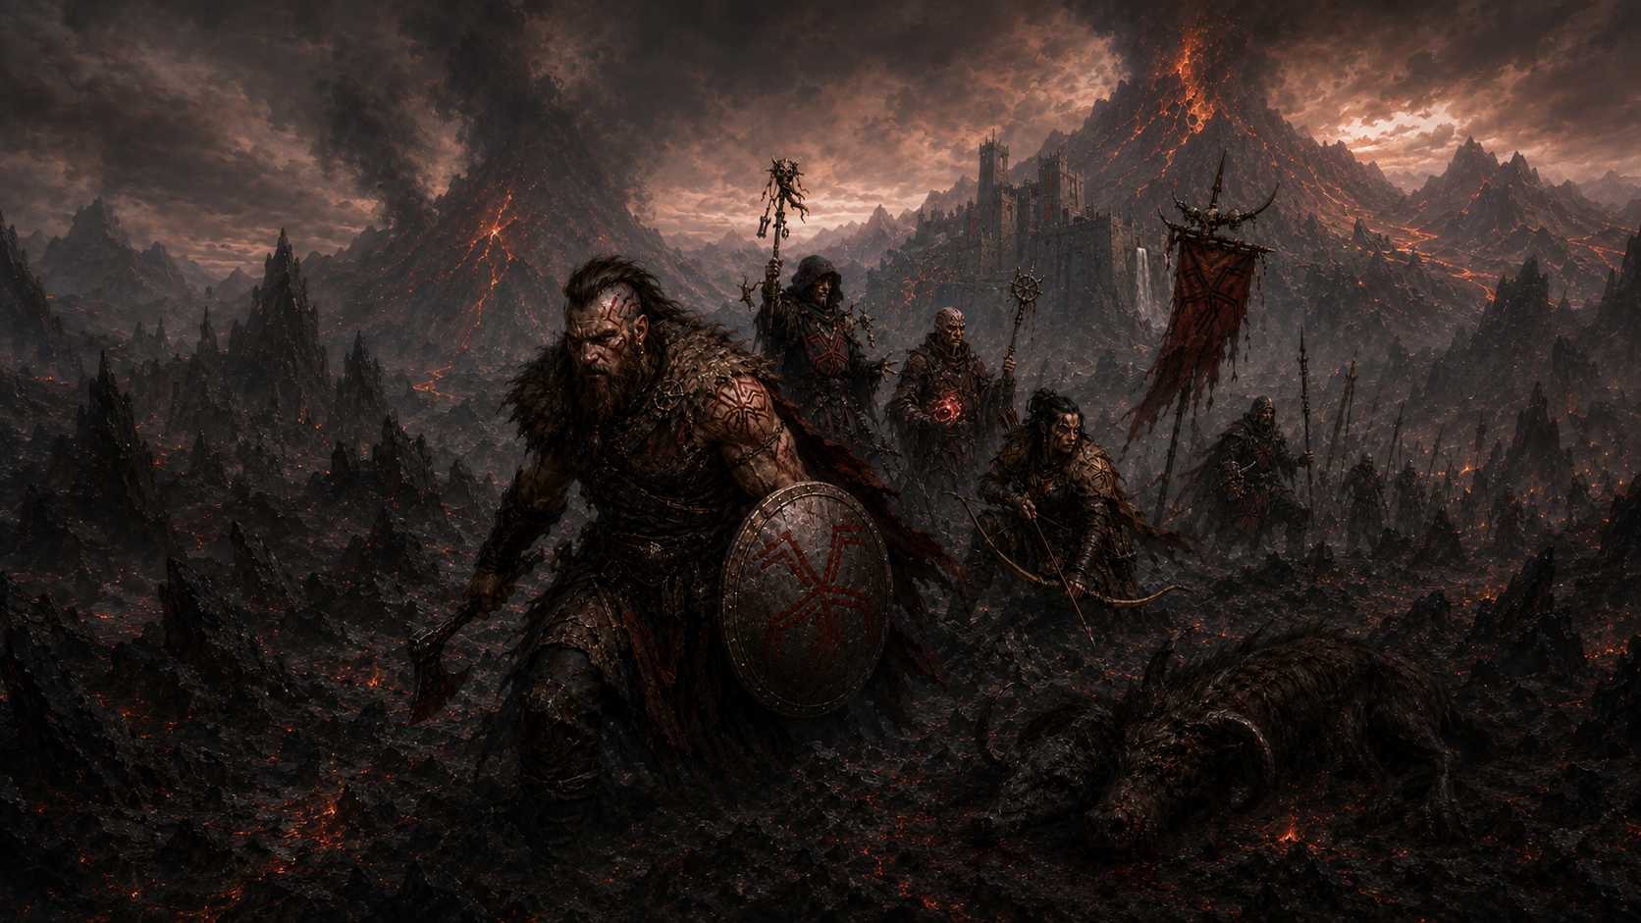
Entropic Prisma (also known as Red Prisma) is Decay made manifest.
Elements: Fire, Magma, Necrosis, Poison
Animals: Predators, Insects
Deity: Entropos

Color: Red
Philosophy: Decay
Neighbors: Invigorated and Animated

v
Lower Order Domain
Entropic Prisma
Decay represents the qualities of cyclical destruction, rebirth, and resilience. Natural phenomena and creatures embodying this principle are often thought of as blunt warriors, cherishing what was and holding a reverence for death and the cyclical nature of the world
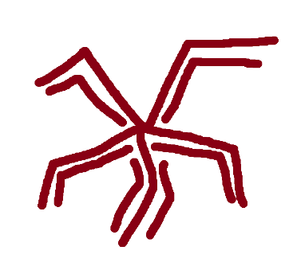
This deep red Prisma presents itself as an atmosphere of weight, decay, and a brutal honesty – very closely tied to fire, volcanoes, and decay. Cultures shaped by Entropic Prisma are defined as meritocratic, fierce, and resilient. Warriors who accept death and dominance as a part of the natural order. Powerful strongholds carved into the landscape – grinding stone into edifice; living creatures into food and elaborate jewelry. These cultures embrace death and decay as cyclical, natural processes that lead to new beginnings – often viewing necromancy and hexes to be just as morally neutral as healing or charms
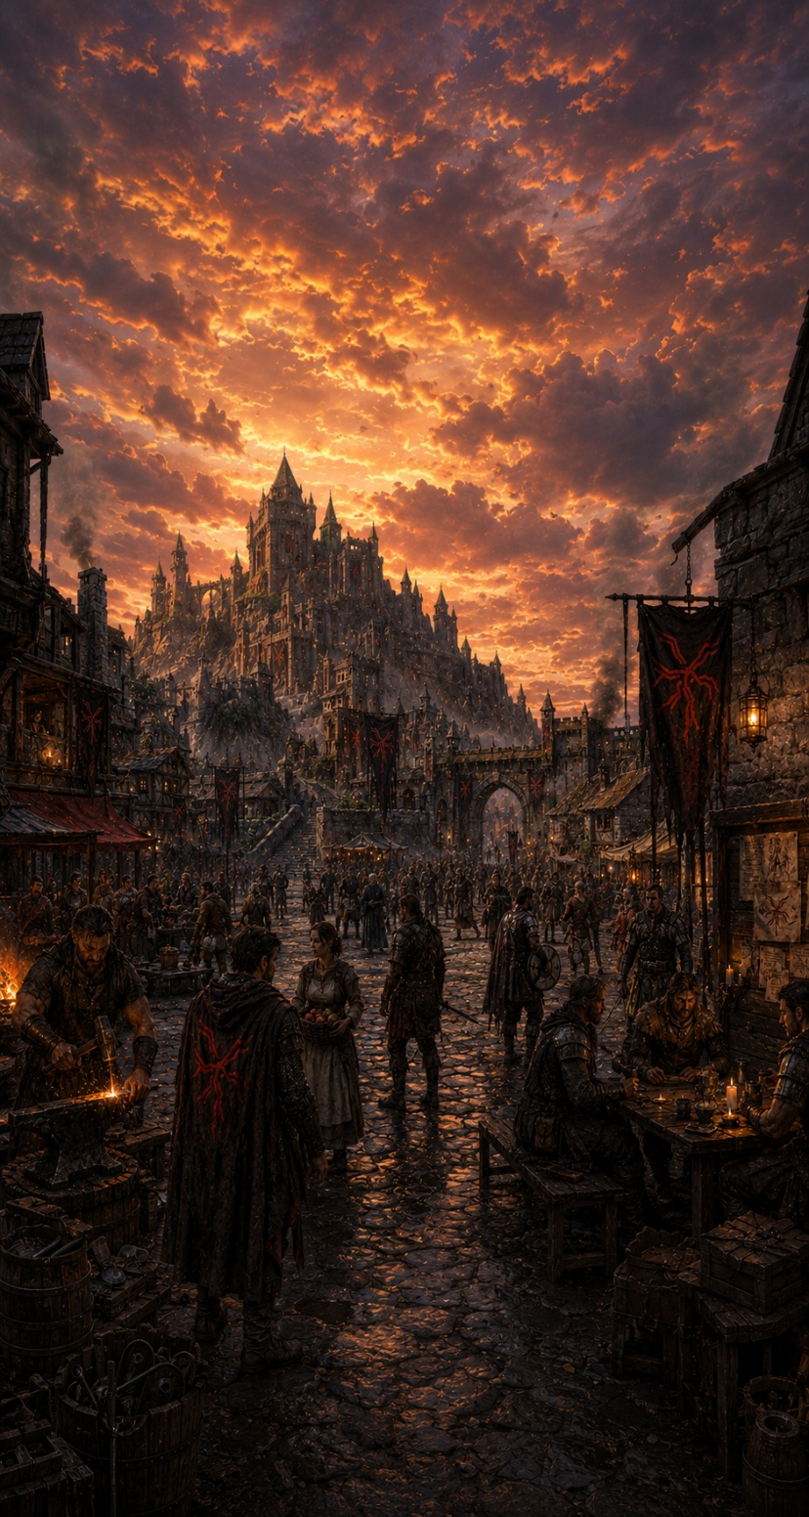
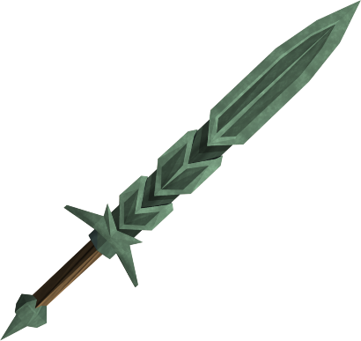
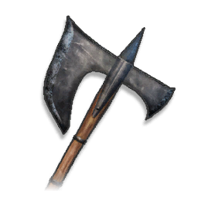
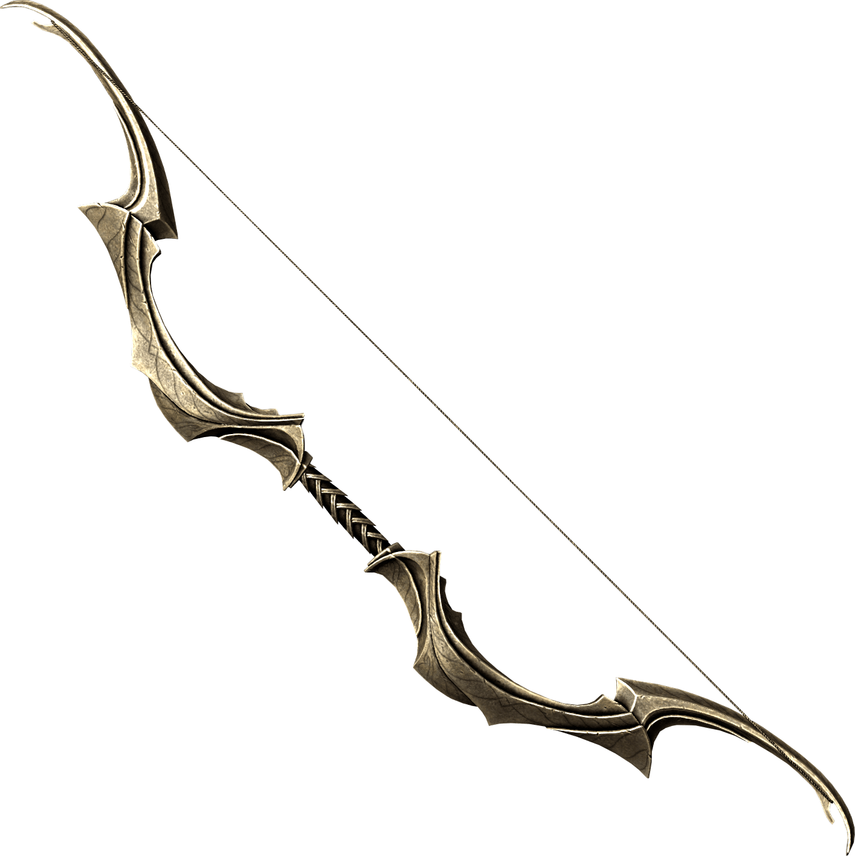
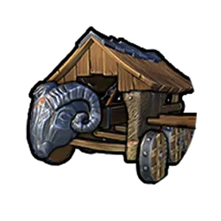
Prima is most potently stained with an Entropic Tint when it comes into contact with Cinderstone; rugged stones formed through the aftermath of heat, magma and ash. When refined, Cinderstone manifests as a silvery glass or metal with a rich green undertone, and lends itself well to simple and effective artifice, such as swords, axes, longbows, and siege vehicles.
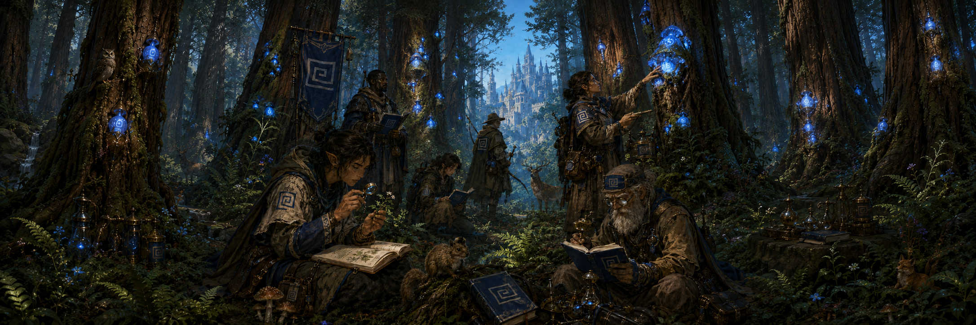
Decaying environments with high amounts of geological activity such as volcanoes and wastelands tend to be intuitively Entropic environments. However, when Entropic Prisma converges in other places, the trademark Cyclical Decay is made manifest. Entropic forests tend to be very wildfire-prone with ecosystems dependent upon frequent burning and regrowth. Red bodies of water tend to run hot with humid and heavy atmospheres, and either look like poison swamps or have high amounts of geothermic activity in their depths. Red caves are known for rivers of lava and creatures that tunnel and reshape the land.
Fabric Prisma (also known as Blue Prisma) is Iteration made manifest.
Elements: Fire, Magma, Necrosis, Poison
Animals: Prey, Mammals
Deity: Fabros

Color: Blue
Philosophy: Iteration
Neighbors: Fortified and Invigorated

v
Lower Order Domain
Fabric Prisma
Iteration represents the qualities of cyclical construction, fortification, and reliable robustness. Natural phenomena and creatures embodying this principle are often thought of as steadfast builders, guided by a future vision and standing on the shoulders of giants to create magnificent wonders.

This rich blue Prisma presents itself as an atmosphere of fertility, organic life, and layered stories – very closely tied to soil, forests, and growth. Cultures shaped by Fabric Prisma are defined as traditional, constructive, and sprawling. Visionaries who create grand structures woven into the landscape itself. Ancient kingdoms; visible far over the horizon containing sprawling archives of stories and artifacts – continuously iterating on the knowledge passed down with each generation; taking up space in the world culturally and physically.
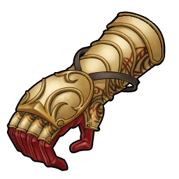
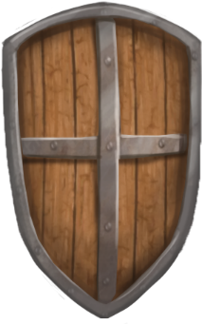
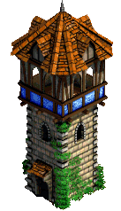
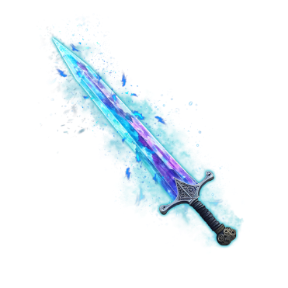
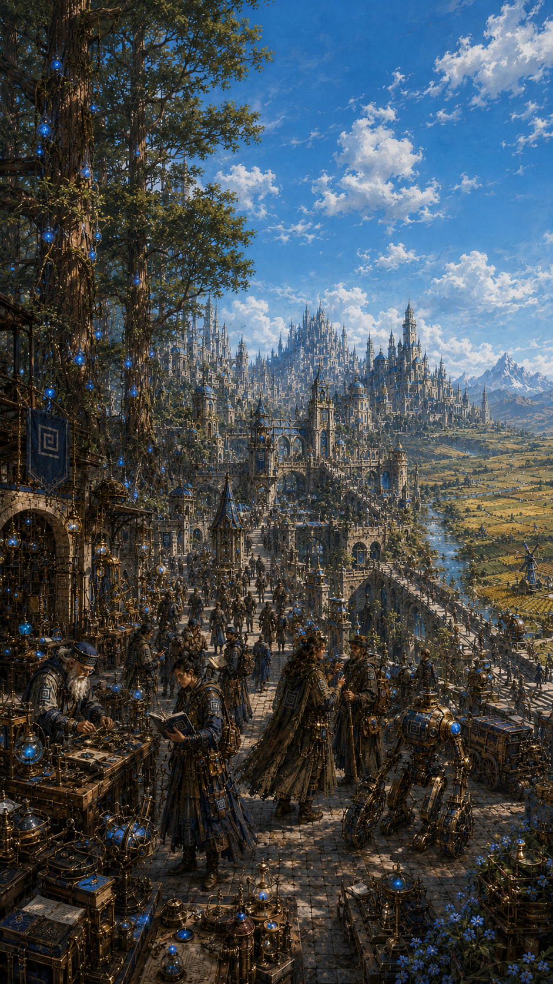
Prima is most potently stained with a Fabric Tint when it comes into contact with Loamstone; a hefty rock formed through the aeons of stone and decomposed matter being packed together. When refined, Loamstone manifests as an amber glass or metal with a subtle orange undertone and lends itself well to sturdy and Prisma-infused artifice, such as gauntlets, armor, shields enchanted weapons, and edifice.
Aged, layered environments with high amounts of biological growth such as old-growth forests and fertile plains tend to be most intuitively Fabric. However, when Fabric Prisma converges in other places, the trademark Iterative growth is made manifest. Fabric bodies of water tend to be slow-moving wellsprings of plant and animal life – often housing pre-historic, ancient life forms that would be long-extinct in other places. Blue volcanoes are long-dormant, towering mountains of thick, hardened, layered stone. And blue caves are overgrown, dormant, and robust - often home to primordial flora and fauna.
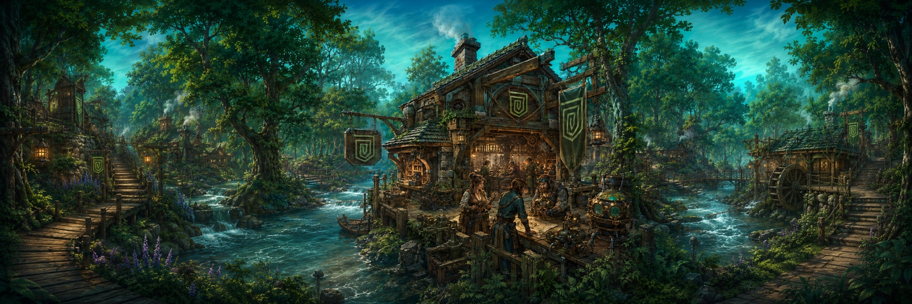



Traits: Wit, Aptitude
Race: Whimweeds
Deities: Fabros, Morphos

Color: Green
Philosophy: Artifice
Neighbors: Fabric and Morphic

v
Higher Order Domain
Fortified Prisma

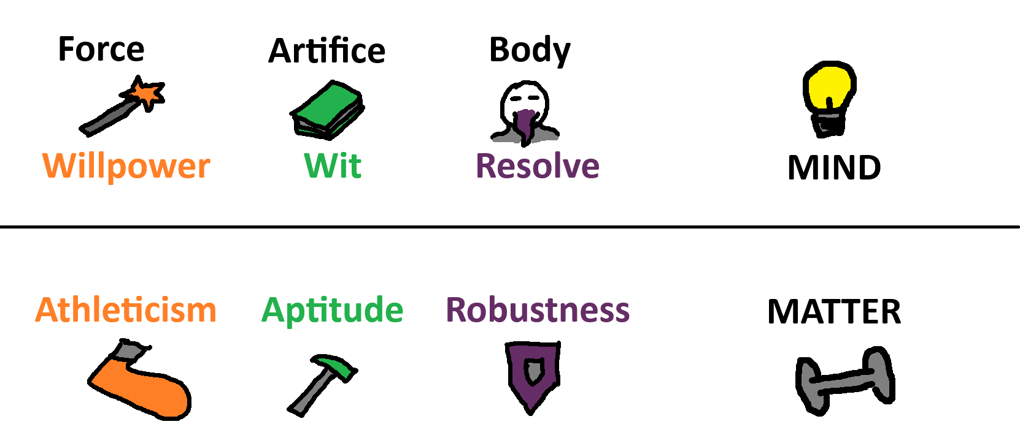
Chapter 2
Playing the Game

The Dice
In the Prismatic Realm, you will face a variety of challenges — from fierce combat to tests of mind and body. Many of these carry uncertain outcomes, determined by a combination of random chance and your own Facets and Capabilities. These outcomes are resolved through a dice roll called a Check.
The exact nature of a Check varies by context, but all Checks follow the same core principles:

Rolling The Dice
A Check involves testing a specific Facet by rolling a number of six-sided dice. The number of dice you roll is equal to half of that Facet's value, rounded down — so a character with 7 WIT would roll 3 dice on a WIT Check.
No fewer than 1 and no more than 3 dice are ever summed when determining the outcome of a Check. This means:
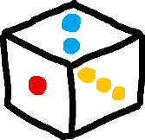
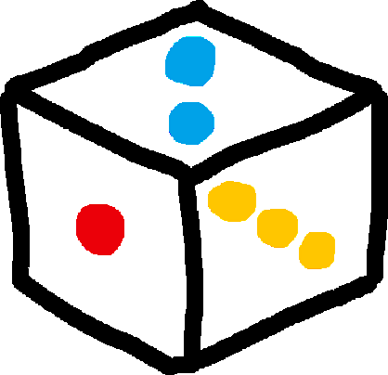

- If you roll more than 3 dice, choose the three highest values and sum those.
- If an effect reduces your dice below 1, additional dice are instead rolled and only the single lowest value is taken. For example, a roll reduced by 1 would roll 2 dice and take the worst result.

Prismatic Bursts
When fewer than 3 dice are rolled, rolling the highest possible value on any die triggers a Prismatic Burst — that die is re-rolled and added to the total, repeating until 3 dice have been rolled in total.
- On a 1d6 roll, rolling a 6 allows you to roll one more die and add it to the total. If that die also rolls a 6, a third and final die may be rolled and added in the same fashion.
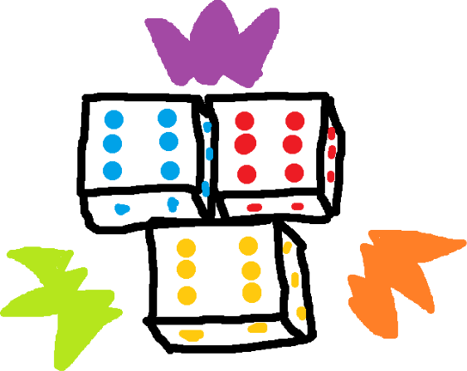
- On a 2d6 roll, if either die rolls a 6, one additional die is rolled and added to the total.

Prismatic Surge
If all 3 dice — whether rolled at once or accumulated through Prismatic Bursts — land on their highest value simultaneously, a Prismatic Surge occurs. This represents a massive stroke of luck and inspiration: roll 3 additional dice and add the total to your result.
Though these additional dice may themselves trigger additional Prismatic Surges - no modifiers, abilities, or bumps may ever be applied to the additional dice, making any chains entirely luck-dependent and infrequent.

Bumping — Boons and Banes
Contextual conditions can increase or decrease the number of dice rolled in a Check through a process called Bumping:
- A Boon of X adds X dice to the roll, representing favorable conditions such as magical enhancements or proper equipment.
- A Bane of X removes X dice from the roll, representing hindrances such as crippling injuries or environmental obstacles.

Capability Checks
Some Checks test not just a Facet but a specific Capability — a trained skill tied to an underlying Facet. Each Capability on your character sheet is represented by a positive or negative annotation alongside a specific die type ranging from d4 to d20.
When a Capability is tested — such as a Navigation check listed as NAV (WIT) +d8 — that die is rolled alongside your standard Facet dice and added to the total. A negative Capability die is instead subtracted from the total, to a minimum result of 1.

The Assist Action
When making a Capability Check with enough time to reasonably seek help, another player or sufficiently intelligent creature may take the Assist Action. This can take one of two forms:
- Oversee — The Assistant takes a supervisory role, lending their expertise. Their Capability die is swapped into the Check in place of yours.
- Take Over — The Assistant steps in and performs the action directly. Their Facet dice are swapped in place of yours.
This dynamic makes it strategically valuable to develop Capabilities that may not align with your strongest Facets — a character with deep knowledge in a field can meaningfully contribute even when their raw ability is lacking, and vice versa.

